VIP – 41: Questions
Two new features have been introduced in VIP 41. We have the following questions in order to define how to proceed with the implementation

Question 1:
A new set of tabs for the VIP accelerator has been added to provide additional incremental rebates.
What we understand: Some products in a few sub-tracks (examples: Enterprise Networks, Enterprise Networks Annuity) are special. The list of the part numbers is tabs called “VIP 41 {subtrack} Accelerator” (where {subtrack}s are VIP Sub Tracks like EN, Collaboration, Data Center, Meraki, SASE, Hy. Work from Off., Hy. Cloud Comp, Hy Cloud Network, Hy Cloud SFTW.)
If quoted during VIP 41 (i.e. the quote effective date is in the duration of VIP 41), these items will fetch additional rebates.
Some of these tabs, like enterprise network Accelerator SKUs, have a defined Accelerator Column. The additional rebates received are equal to the “VIP 41 {subtrack} Accelerator Percentage column” (column D in some of the aforementioned excel tabs).

Question 1a:
Can you please confirm the above assumption?

Some others, like VIP 41 SASE Accelerator, have different levels of Incentives. Some items in these tabs have “SKU Incentive”, and some others have “Land/Expand” and “renewal” incentives separated out.
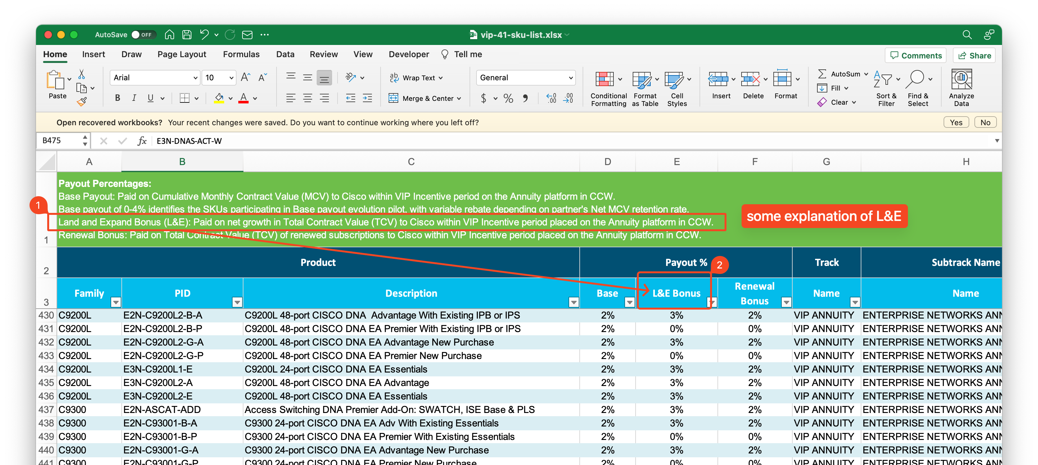

Question 1b:
1b.1: How are the incentives to be calculated in this case above?
1b.2: How can PQW identify if we are to use “Land/Expand” or “Renewal” for a given deal? Are there any specific indications in the Deal Registration?

Summary of Question 1
In General, I think we need to discuss and understand how the different types of bonuses and incentives are working together:
- In the Precedence Rules section of the Incentive Rules Document (page 7), points #4 and #5 define the precedence of different tracks. Does this mean that all sub-tracks of the preceding track precede all the sub-tracks of the track with lower precedence?
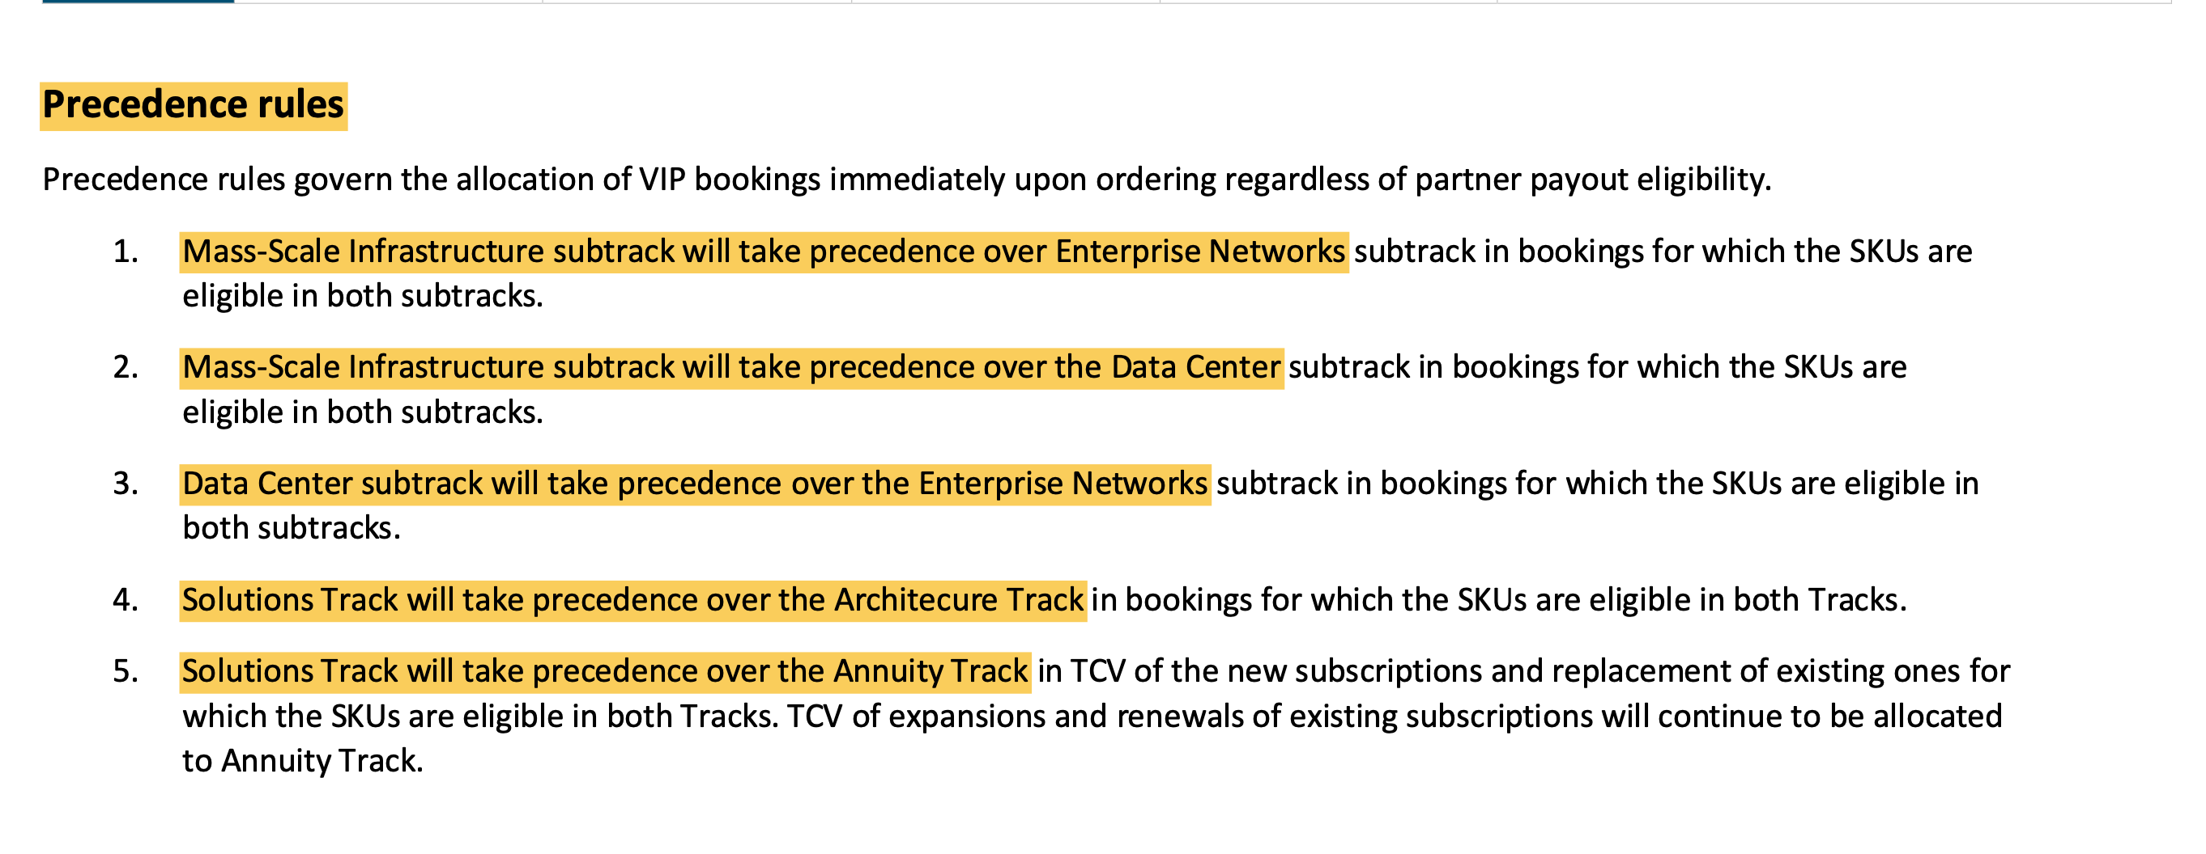
- Payout / Base payout
  - Item LIC-MX95-SDW-5Y has a base payout defined as 4% in the “Meraki” tab
- SKU incentive (Non-Accelerator)
  - What is the difference between Base Payout and SKU Incentive which is not an accelerator?
  - What happens when an item has both an SKU incentive and a Base payout?
    - LIC-MX95-SDW-5Y
- Accelerators
  - What happens if the item has a base payout as well as an accelerator => We add the accelerator to the Base Payout.
  - What happens if it has two (or more) accelerators defined?
    - Example (Item LIC-MX95-SDW-5Y has Meraki Accelerator of +6% defined)
    - Item LIC-MX95-SDW-5Y also has +6% of SKU Incentive SASE Accelerator defined
    - So, is the net accelerator of this item +12%? Or is it +6% only following similar precedence as defined in the Precedence Rules section in Incentive Rules Document?

Question 2:
What is the mechanism to find/track/validate the Net MCV retention rate that will be applicable when creating a quote in PQW? The VIP Selling Guide says on page 30 that it will be sent manually via email, and can only be calculated AFTER the VIP period ends.
Do we need to provide a way to “trigger” a recalculation after the VIP period ends for all the quotes that were quoted during the last (or specific) period, and how can StrataVAR PQW get the data?
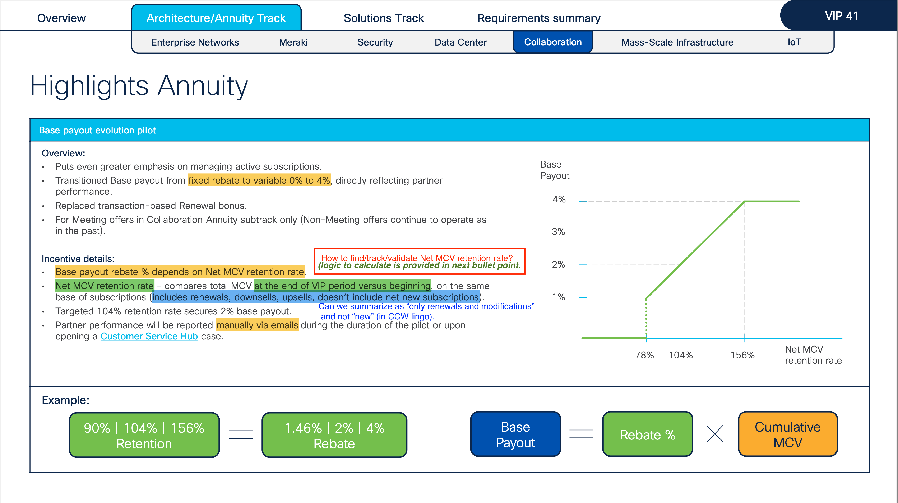

The VIP Incentive Rules document says that the Net MCV will be reported monthly (screenshot below). How can it be reported monthly if Net MCV can only be calculated at the end of the VIP period (green highlight in screenshot above)?
Will Cisco provide some kind of “rolling” data?
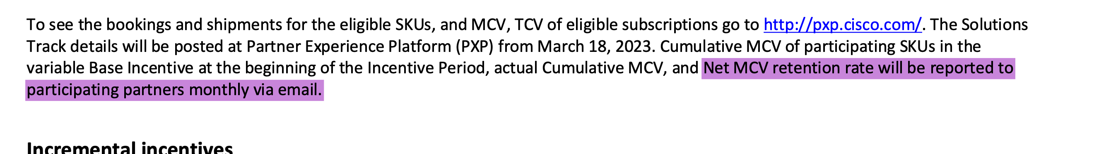

Question 2a:
We understand that the new “variable base payout” is only applicable to “some” items – items that have the payout defined as “0-4%” in the Base column in the VIP Payout Excel. For others, where the Base is defined as a fixed value (like “2%”), the 2% will be applicable irrespective of the MCV.
Cisco Quote from Collaboration Annuity Tab:
A base payout of 0-4% identifies the SKUs participating in the Base payout evolution pilot, with variable rebate depending on the partner's Net MCV retention rate.
Can you please confirm?
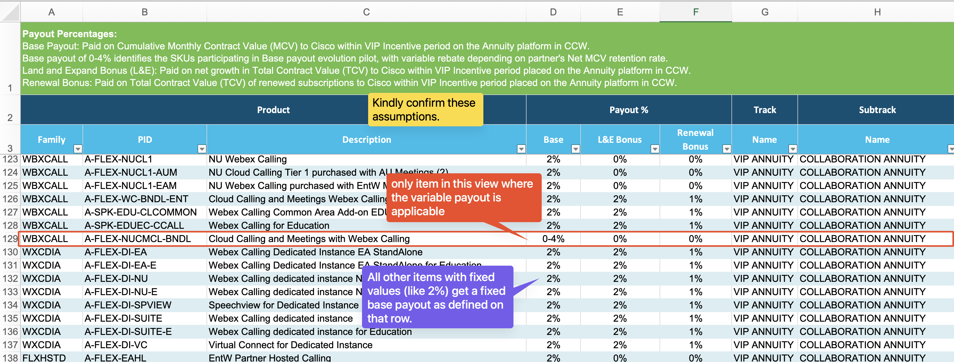

Question 2b:
What does “104%” retention mean? Does it mean a 4% upsell?

Question 3:
We are unable to get to the Partner Platform at http://pxp.cisco.com/ mentioned in the document.
